


School Authority Employment Submission (SAES)
Batch Upload Guide
Version 0.1
November, 2014

Table of Contents
1 Introduction 4
1.1 Definition of key terms 5
2 Submission Processing and Timelines 6
2.1 Rules for Multiple Submissions 6
3 Accessing School Authority Submissions (Extranet) 7
3.1 Accessing School Authority Employment Submission 7
3.2 System Requirements 8
3.3 Technical Support 8
4 Batch Certificated Staff Employment Submission 9
4.1 Login to the Extranet 9
4.2 Open TWINS Application 10
4.3 Submit School Employment Batch File 11
4.4 Submitting a Certificated Staff Employment Submission 12
5 Creating an XML Batch File 17
6 Creating a CSV Batch File 18
6.1 Creating .CSV file using Microsoft Excel 19
6.1.1 Saving (.CSV) file with Microsoft Excel 20
7 Extracting a CSV Batch or XML Batch File 23
7.1 Extract current Certificated Staff Employment Information 23
7.2 Select ‘Save as’ 23
7.3 Save Extracted File in Desired Folder Location 24
8 Frequently Asked Questions 25
Appendix A - Snapshot Data Format and Rules 27
Appendix B - SAES XML Schema (.XSD) 43
Appendix C - Submission File Event Data Fields 46
Appendix D - Error Messages and Exceptions 51
Appendix E - Access Request 60

Introduction

At the beginning of each school year Alberta School Authorities are required to send a School Authority Employment Submission (SAES) batch snapshot. A batch snapshot should contain at least one record for every active certificated staff employed in the school authority to Alberta Teacher Registry.

School authorities are to report all certificated staff that are actively employed at the start of the school year. Subsequently, they are to report all changes to employment throughout the remainder of the school year.

The Initial Fall submission should reflect the employment status of all certificated staff as of September 1 of the current school year. Subsequent batch or event submissions to update employment records are requested to notify Alberta Education of employment changes. They may be submitted at any time following the Initial submission.

The School Authority Employment Submission serves the following purposes:

- It is used by Teaching and Leadership Excellence to provide information to school authorities regarding staff with expired or expiring teaching authority.
- It is used by Teaching and Leadership Excellence to ensure that certificated staff currency of practice is updated. This is required for teachers to maintain certification.
- It will be used to enable certificated staff access to LearnAlberta.ca website such as multimedia resources and the Online Reference Centre.
- It provides aggregate data for Statistics Canada. The data is also provided to Alberta Education to create forecast scenarios for student population and teacher demand.
- It may be used by other Ministry divisions to verify certificated staff in order to meet requirements for various programs.
- It meets the Registrar’s requirement under section 15(1) of the Certification of Teachers Regulation to maintain a registry of information, including personal information of individuals who apply for or hold a certificate, who request an evaluation of their credentials, who held a certificate that has expired, been suspended or cancelled in Alberta or elsewhere or who are designated signing officers.

This information may be submitted either via an online screen (suited for manual entry of a small number of individual records) or by a batch file upload. The rest of this manual describes the batch upload process.

Definition of key terms
Snapshot: A full report of the state of certificate staff as of a specified date typically extracted from school authority systems. A batch snapshot must include one record for every certificated staff position in effect within the school authority. One record is required for each certificated staff member for each school based or non-school based position they hold.
Initial Submission: The first submission within a school year should be a full report of certificated staff employed at the outset of the current school year (i.e. September 1). Full batch corrections to the initial submission can be made if submitted within the Initial submission window (but only if no intervening events have been submitted). An update may be submitted at any time following the Initial submission.
Event: An employment event is an activity of interest that happened at a moment in time. Examples are Leave, Return from Leave, Hire, ReHire, Termination. An individual event may be submitted at any time within the school year provided an initial submission has been submitted for that school year. Events that do not update a snapshot may be submitted for the preceeding school year at any time during the current school year. Examples are Leave, Return From Leave, Termination.

Submission Processing and Timelines
Certificated staff employment submission uses the following process:

- Designated school authority staff collate certificated staff employment information including: certificate number, personal contact information, school, position, FTE count, and grade assignment (see details below).

- Designated school authority staff submits the information by a batch file through the Extranet site at https://phoenix.edc.gov.ab.ca/login/default.asp and receives a conformation email of successful submission.

Teaching and Leadership Excellence staff verify submitted information and contacts the designated school authority staff to follow up when there are conflicts in reporting and to provide an Expiring Teaching Authority report.

An Initial submission is expected to be the first information submitted by a particular school authority for the current school year. It is an error to submit an event within the current school year prior to submitting the Initial submission file.

More than one record for a single certificated staff member can be entered in a submission period if the school code is different for the records submitted. If more than one record for a certificated staff member is entered in a single submission period where the school code is the same, or no school code is specified, an exception will be generated (Please see Appendix D - Error Messages and Exceptions for handling exceptions and errors).

Rules for Multiple Submissions
If for any reason the Intial submission is incorrect a subsequent correction file can be submitted. The correction file replaces the previous information reported for the school year. It must contain a complete set of certificated staff for the submitting school authority.

There are no limits to the number of correction submissions except:
- Correction batch files can only be submitted prior to a cutoff date specified by Teaching and Leadership Excellence Sector.
- No event data pertaining to the current school year has been submitted.
Snapshot files submitted after the cutoff period will update certificated staff records where differences exist, add any new certificated staff not already reported for the school authority and end-date any missing positions.

Accessing School Authority Submissions (Extranet)
Access to SAES is through the Extranet https://phoenix.edc.gov.ab.ca/login/default.asp, a secure, authenticated electronic information service providing confidential data to Alberta Education Stakeholders for the purposes of carrying out their duties and responsibilities within the organization.

Accessing School Authority Employment Submission
In order to access the SAES in TWINS from the extranet:
- An authorized extranet user completes and submits the TWINS (Teacher Registry) Authorization Form.
- The Registry Manager authorizes access and notifies the Alberta Education Client Service Help Desk.

The Client Service Help Desk contacts the user with verification of access to the TWINS application for the purposes of submitting the SAES.

Note: School authorities are required to notify the Registry Manager immediately if a staff member no longer requires access to SAES, so that access privileges may be revoked.

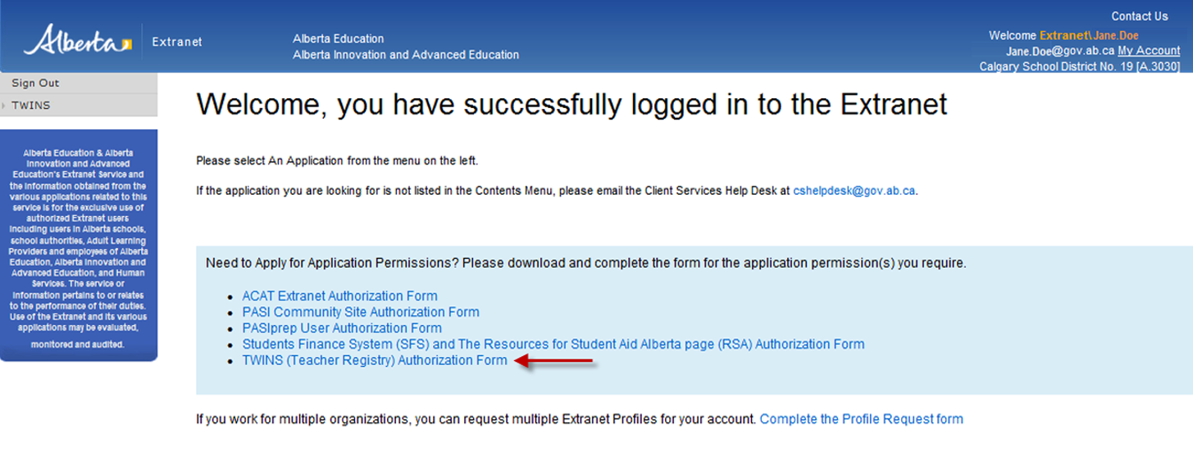

System Requirements

This is a secure site that requires a user specific login. Users need to have the following in order to login and use the Certificated Staff Employment Submission process:

- Screen resolution of 1024 X 768
- 128-Bit SSL connection
- Ensure that your pop-up blocker allows for pop-ups from this site.
- Optimized for IE 8

Technical Support
If you require assistance with access to extranet online services or the submission process, please contact the Business Analyst or Registry Manager by toll-free access within Alberta, first dial 310-0000 (780) 427-2045 or by e-mail at TWINS@gov.ab.ca.

Batch Certificated Staff Employment Submission

Certificated Staff Employment Submission updates are performed in one of two ways. A school authority can:

- Create a new SAES file in either .xml or .csv format and then submit the file through the Extranet.
  - See section Creating a CSV Batch File for .csv format
  - See section Creating an XML Batch File
- Extract and update current Certificated Staff Employment information and then submit the file through the Extranet.
  - See section Extracting a CSV Batch or XML Batch File

Once an authorized user has been granted access to the Certificated Staff Employment Submission process the user will be able to perform the following:

- Login to the Extranet.
- Open the TWINS application and select Employment Submission Batch from the left menu.
- Submit the file.

A submission cannot be created or submitted if the last submission from your school authority has not been completely processed by the TWINS application. This is to ensure the integrity of the information by preventing multiple submissions at one time. If you believe you should be able to submit information, contact the Business Analyst or Registry Manager at (780) 427-2045 (toll free by dialing 310-0000).

Login to the Extranet
The Alberta Education and Advanced Education and Technology Extranet site is the main portal for accessing the certificated staff employment submission process.

The Extranet site can be accessed at https://phoenix.edc.gov.ab.ca/login/default.asp. Log into the site by providing your email and password.

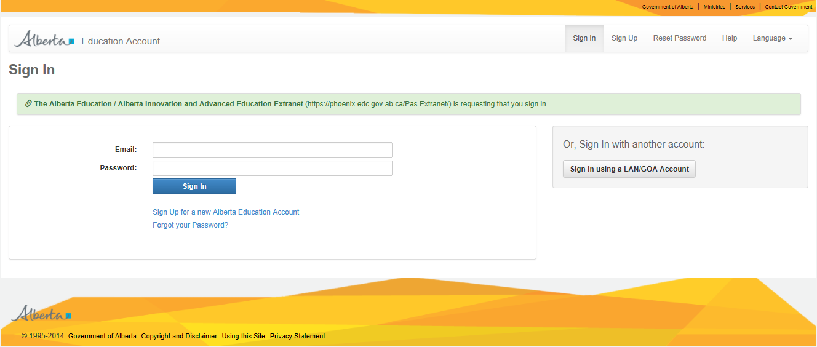

Open TWINS Application
Once an authorized user has logged into the secure website, the user should see the TWINS application link on the left navigation bar on the screen. If this is not the case, contact the Business Analyst or Registry Manager at Teaching and Leadership Excellence Sector.

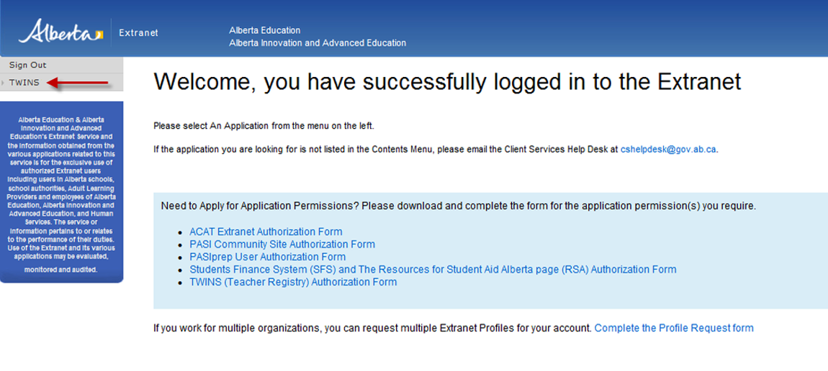

Submit School Employment Batch File

From the TWINS home page the authorized user must select ‘Employment Submission Batch’ from the menu options on the left.

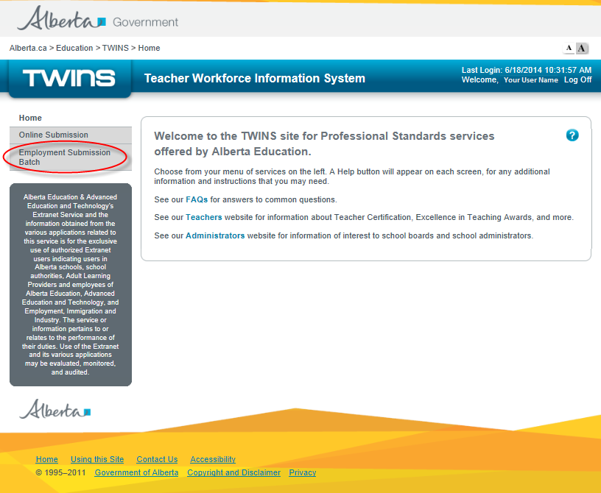

Submitting a Certificated Staff Employment Submission

Click on the ‘Employment Submission Batch’ menu option. The Submit Teacher Data screen will be displayed.

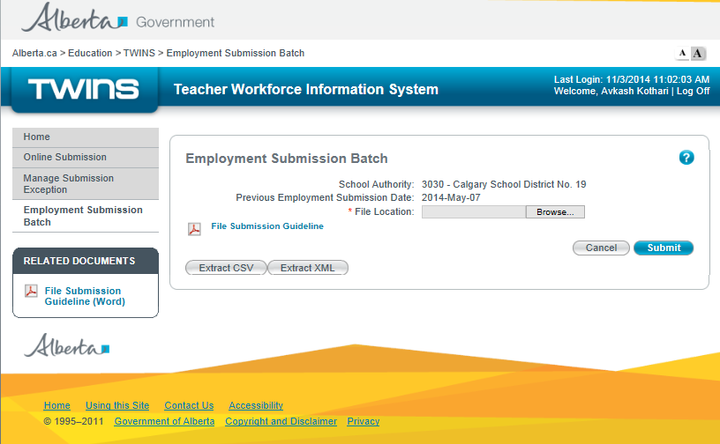

Click on the Browse button. The system will open a dialogue box that allows you to choose the desired file. Locate and select the file to be submitted by highlighting the file name. Click on Open to select the file.

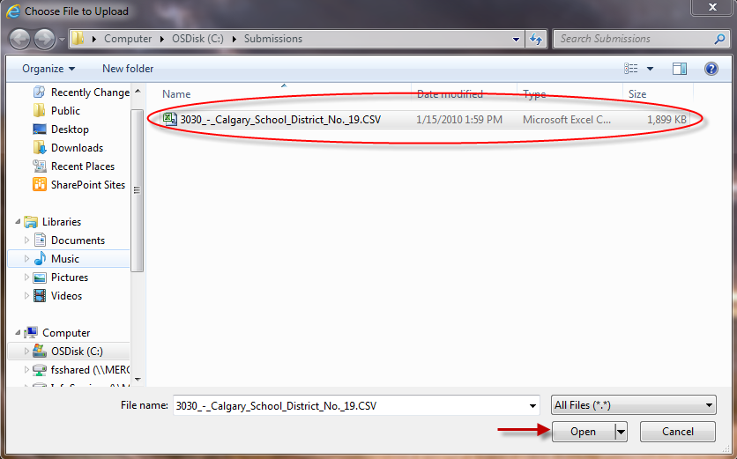

Click on the Submit button.

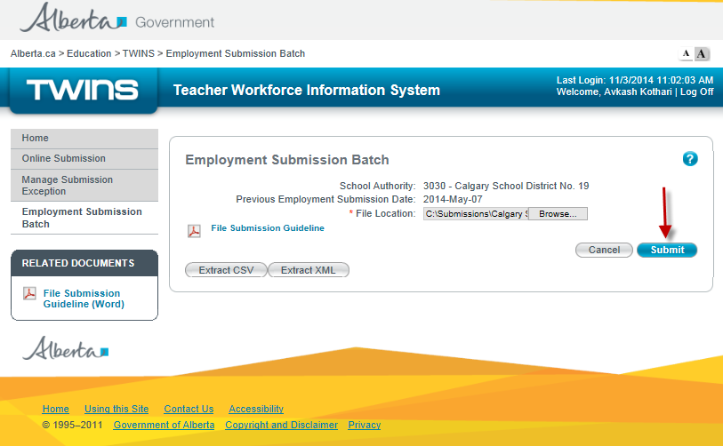

If there are no errors, a confirmation message will appear on the screen. Once TWINS has processed the submission, a confirmation will be sent to you via e-mail. The confirmation email can take several hours, depending on the number of records that are submitted.

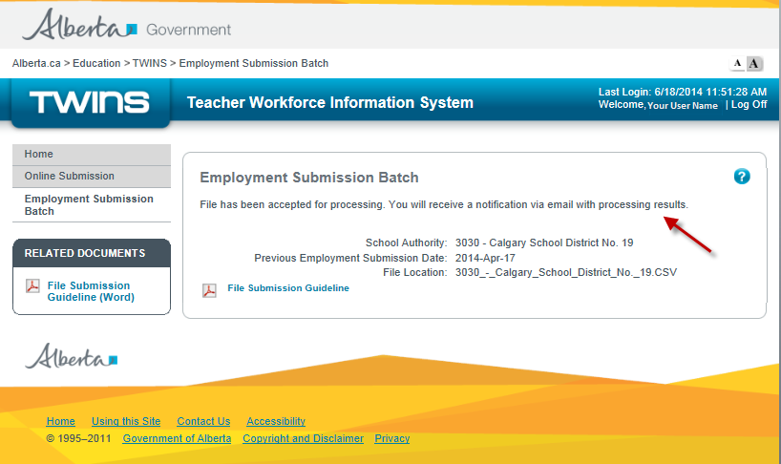

If there are file format errors, such as incorrect number of fields, an error message will appear on the screen. Any other validation errors(i.e. non-format errors) will not be shown on screen but will be sent to you via email. Please refer to for examples.

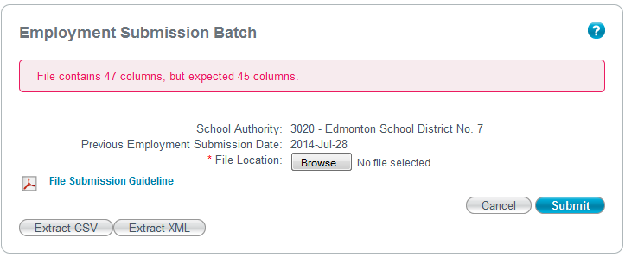

Only one submission can be can be processed at a time. If a file has already been submitted but not yet processed, the following will appear:

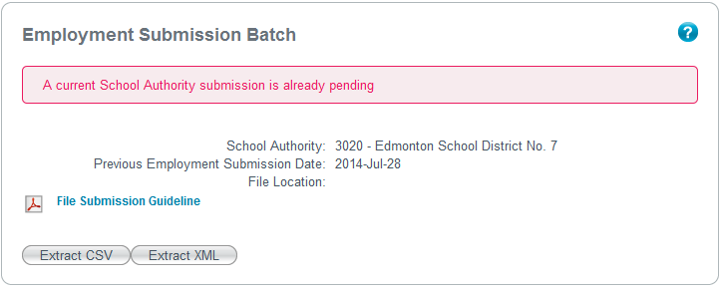

Logoff and close Extranet.

Creating an XML Batch File
Certificated staff employment submission updates may be submitted though a batch file in .xml format. Files for batch submission cannot be created in the Extranet application. A school authority must create this file separately and then submit it through the Extranet.

Please see Appendix B - SAES XML Schema (.XSD) and Appendix C - Submission File Event Data Fields

Creating a CSV Batch File
School authority employment submissions may be submitted though a batch file in .CSV format. Files for batch submission cannot be created in the Extranet application. A school authority must create this file separately and then submit it through the Extranet.

Submit one record for each certificated staff member active at any time during the reporting period. If the staff member has worked in multiple schools within the school authority, submit one record for each school code where there was an assigned position. One position where the certificated staff member is not school specific (i.e. no school code) may also be reported (e.g. substitute teacher). Do not submit multiple records for the same certificated staff member with the same school code.

.CSV is a text file format used to store database entries. Between each data record (row), there must be a carriage return character (0xd). If there are any commas, carriage returns, or pipe characters in the data elements within the CSV file, then the data element must be wrapped within quotes (“”) (0x22).

There are several methods to create CSV files. The most common are using Microsoft Excel or using a text editor such as Notepad.

Creating .CSV file using Microsoft Excel
Open Microsoft Excel.

Please do not use column headers in the table.



Saving (.CSV) file with Microsoft Excel
Once you have completed adding data and you are ready to save the file in .CSV format.
Locate the “Save” button and click “Save As”.
Select “Other Formats”.

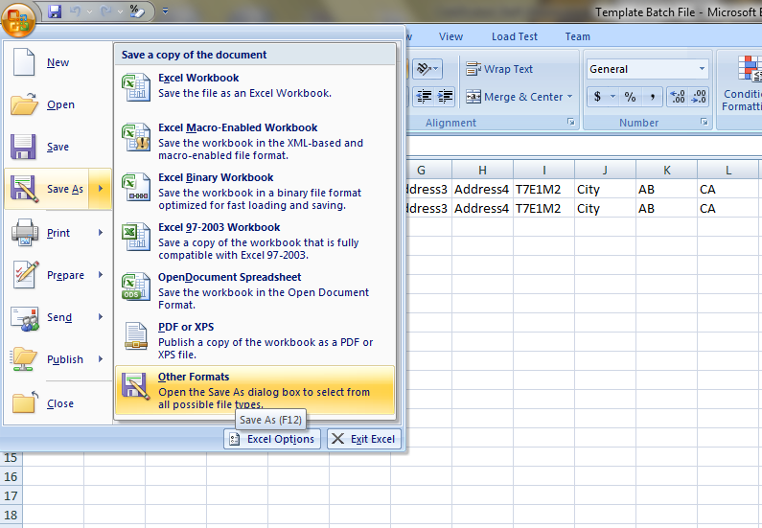

Using the drop-down menu select the file type .CSV (comma delimited).

Type the name of your file. The file name must contain the school authority code, school authority name, and submission period. Example: 1234ASchoolAuthority_2014.csv.

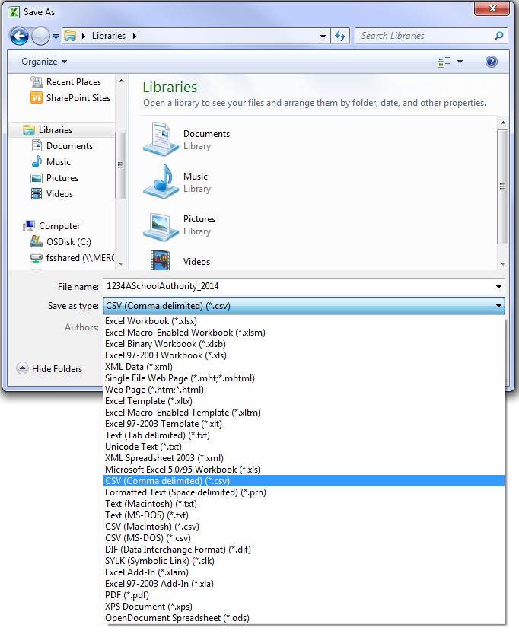
Click "Save".

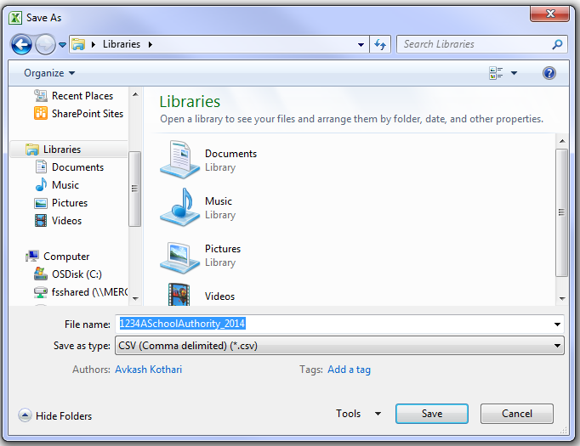

Click “Yes” to the dialog that pops up.
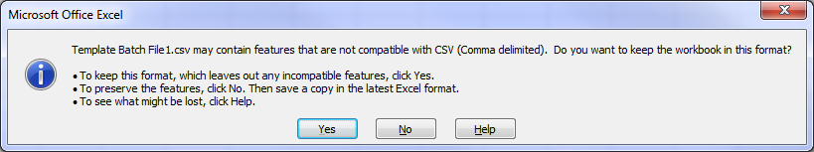

Extracting a CSV Batch or XML Batch File
An extract is created from the current Certificated Staff Employment information. The information can be updated after the file has been saved and then submitted using the steps defined in Batch Certificated Staff Employment Submission section of this document.

Extract current Certificated Staff Employment Information

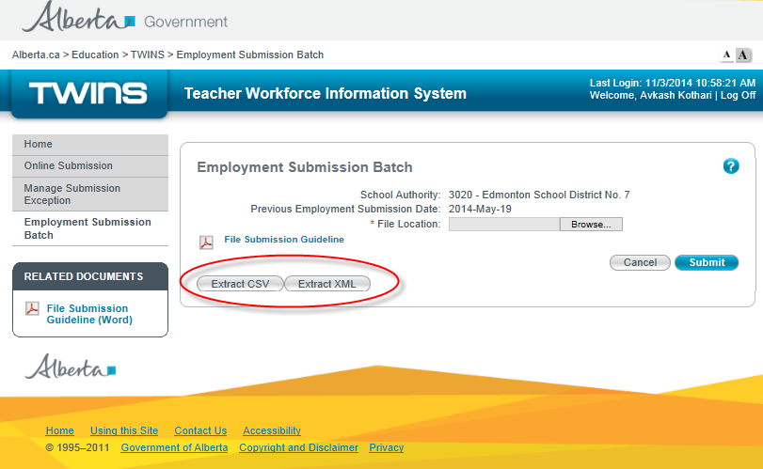

Select ‘Save as’

Save Extracted File in Desired Folder Location

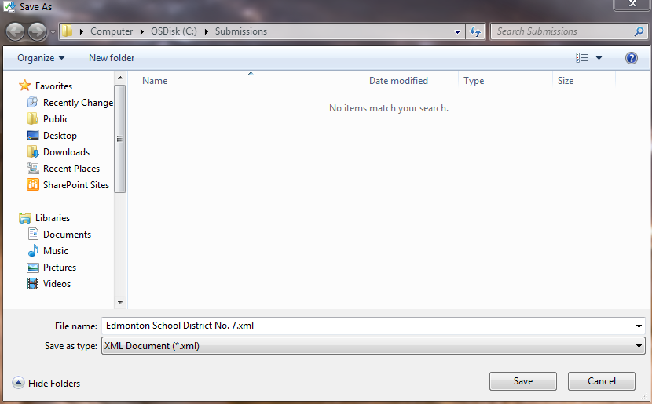

Frequently Asked Questions
WHY SUBMIT CERTIFICATED STAFF EMPLOYMENT INFORMATION ELECTRONICALLY?

It is convenient and secure. Electronic submission is easier: no paper forms to fill out and mail or fax, and it creates a permanent record for easy retrieval. It will also help generate better data, reduce process times, and the amount of effort devoted to GOA administration by School Authorities.

WHAT HAPPENS AFTER YOU CLICK”SUBMIT”?

The system confirms you have completed all mandatory fields and that the type of data entered is appropriate. For instance, you cannot enter a word in a date field. If there are errors or missed information you will be notified that the submission contains errors. You will be requested to revise any exception errors for that submission. (See Appendix B)

HOW WILL I KNOW MY SUBMISSION WAS RECEIVED?

Once the file has been successfully submitted you will receive an onscreen message telling you that your submission has been accepted. You will also receive a confirmation email. The confirmation email can take several hours, depending on the number of records that are submitted. If you have not received a confirmation email, please contact the Business Analyst or Registry Manager.

WHAT DO I DO IF I AM HAVING PROBLEMS USING THIS SYSTEM?

There are several resources available to assist you such as:

Registry Support Team
Please contact the Business Analyst or Registry Manager, by toll-free access within Alberta, first dial 310-0000 (780) 427-2045 or via email TWINS@gov.ab.ca.

Error Messages
If the system detects errors or omissions with the submission (for example: format) or if one of the mandatory fields is not completed, an error message will be displayed. These errors must be corrected before the information can be resubmitted to the system.

IS THE SYSTEM SECURE AND CONFIDENTIAL?

TWINS application ensures security and confidentiality by:

Using industry standard 128 bit SSL encryption, similar technology to that used in online banking.
Providing a unique User ID and Password for every user, as well as a historical record of the activities performed under each user ID.
WHAT DO I NEED TO KNOW ABOUT FREEDOM OF INFORMATION AND PROTECTION OF PRIVACY (FOIP)?

Teaching and Leaderhship Excellence Sector is subject to the Freedom of Information and Protection of Privacy Act (FOIP). All information collected through the TWINS application is managed based on the requirements of the Freedom of Information and Protection of Privacy Act.

CAN I CHANGE A SCHOOL AUTHORITY EMPLOYMENT SUBMISSION SUBMITTED EARLIER TO ADD NEW OR UPDATE INFORMATION?

Please refer to Rules for Multiple Submissions section of this document.

WHAT INTERNET BROWSER CAN I USE?

TWINS is optimized for Internet Explorer 8

I CAN’T LOG IN!

Here are a few things to keep in mind when trying to log in:
- Ensure that you are at the correct login site. The address shown in the address bar of your web browser should read: https://phoenix.edc.gov.ab.ca/login/default.asp
- Ensure your User ID is correct.
- Ensure the password is correct. The password is case-sensitive.

Appendix A - Snapshot Data Format and Rules
Below are the standard definitions, expected format and rules of the data fields used within the system.

The CSV format has one teacher record per row with data elements separated by commas. The TWINS application reads the values in the .CSV file as text and then converts internally to the data types identified in the following table.

The following table provides the definitions for the corresponding CSV format

Column  (When using Excel) | Field Name | Definition | Format | Rules |  | Delimiter
A | Certificate Number | This is the unique alphanumeric identification number assigned to every individual who has applied for teaching authority within Alberta. The certificate number may be used as look up criteria in the Teaching Authority Validation System. | Alphanumeric  7 characters  Formatted as NNNNNNA | Required.  Value of 999999A is accepted when the actual Certificate Number is unknown. |  | , (0x2c)
B | Surname (‘Last Name’) | The Last Name field consists of the certificated staff member’s current legal surname as documented on a vital statistics document. | Alphabetic, with space, hyphen, and apostrophe allowed. French language characters are accepted.  Max: 35 characters | Required. |  | , (0x2c)
C | Given Name (‘First Name’) | The First Name field consists of the certificated staff member’s legal given name as documented on a vital statistics document. No abbreviations. | Alphabetic, with space, hyphen, and apostrophe allowed. French language characters are accepted.  Max: 35 characters | Required. |  | , (0x2c)
D | Middle Name | The Middle Name field consists of the certificated staff member’s legal middle name as documented on a vital statistics document. No abbreviations. | Alphabetic, with space, hyphen, and apostrophe allowed. French language characters are accepted.  Max: 35 characters | Optional |  | , (0x2c)
E | Address Line 1 | This is the street address (or delivery address) for certificated staff member’s legal residence. | Alphanumeric, with space, hyphen, apostrophe, slash, and period allowed. French language characters are accepted.  Max: 64 characters | Required. |  | , (0x2c)
F | Address Line 2 | (as needed) | Alphanumeric, with space, hyphen, apostrophe, slash, and period allowed. French language characters are accepted.  Max: 64 characters | Optional |  | , (0x2c)
G | Address Line 3 | (as needed) | Alphanumeric, with space, slash, hyphen, apostrophe, and period allowed. French language characters are accepted.  Max: 64 characters | Optional |  | , (0x2c)
H | Address Line 4 | (as needed) | Alphanumeric, with space, slash, hyphen, apostrophe, and period allowed. French language characters are accepted.  Max: 64 characters | Optional |  | , (0x2c)
I | Postal / Zip Code | The Postal Code for Canadian and US residence must comply with the Universal Postal Union addressing standards. | Alphanumeric, hyphen, and space allowed.  Max: 10 characters  Formatted as:  ANA NAN (Canada),  or  NNNNN-NNNN (US) or  NNNNN (US) | Conditional – required if Country is either Canada or United States; otherwise optional |  | , (0x2c)
J | City |  | Alphanumeric, with space, hyphen, apostrophe, and period allowed. French language characters are accepted.  Max: 64 characters | Required. |  | , (0x2c)
K | Province / State | The 2-digit abbreviation for the province or state of the certificated staff member’s mailing address. | Alphabetic  2 characters | Conditional – required if Country is either Canada or United States; otherwise optional |  | , (0x2c)
L | Country | Valid 2-digit country code abbreviation | Alphabetic  Min: 2 characters  Max: 2 characters | Required  Must be a valid country abbreviations (Canada post standards) |  | , (0x2c)
M | Phone Number | This is the primary telephone contact number for the certificated staff member. Include area code. | Numeric and hyphen and space allowed.  12 characters  Formatted as 999-999-9999 | Optional |  | , (0x2c)
N | Email Address | The work email address assigned to the staff by the school authority, if available. Personal, group or general-office email addresses should not be submitted. | Alphanumeric, must be a valid email address.  Max: 64 characters | Optional |  | , (0x2c)
O | School Code | The school code is the four digit numeric code assigned by Alberta Education. The code is required for certificated staff in school-based positions. Do not use your school authority code. Leave blank for staff unassigned to a school. | Numeric  Leading zeroes within the code should be included  4 characters | Conditional.  Must be a valid school code associated with the submitting school authority for the employment submission period. |  | , (0x2c)
P | Position | This is employment position that a certificated staff member holds.  Please refer to the table at the end of Appendix A for code values relating to their respective positions. | Alphabetic  3 characters | Required.  Must be a valid position code value. |  | , (0x2c)
Q | School-Based Position? | Indicates whether or not the position that a certificated staff member holds is based on employment within one school only. | Alphabetic  1 character | Required.  Y or N |  | , (0x2c)
R | FTE in Position (Percent) | This indicates the portion of a full-time equivalent (FTE) resource that the certificated staff member has filled (or is expected to fill) in the position reported.  Certificated staff who are employed in a full-time capacity for ½ of the school year would be reported as 1.00 FTE, the same as someone employed in a full-time position for the entire school year. | Numeric –  3 decimal places  5 characters (with decimal placeholder)  Example: 0.750 | Mandatory  Cannot exceed value of 1.000  Enter a value of 0.000 for Position of ‘Substitute’. |  | , (0x2c)
S | FTE in Teaching Assignment (Percent) | This indicates the portion of a full-time equivalent (FTE) resource that the certificated staff member has filled (or is expected to fill) in a teaching assignment, based on a full school year.  A person working full-time in a position of ‘Teacher’ would be reported with an FTE in Position of 1.00 and an FTE in Teaching Assignment of 1.000  A person working full-time in a position of ‘Assistant Principal’ with 25% of that time spent in classroom instruction would be reported with an FTE in Position of 1.00 and an FTE in Teaching Assignment of 0.250  This data should be reported for any certificated staff member with any teaching assignment or instructional duties, regardless of the primary position or role held. | Numeric – 3 decimal places  5 characters (with decimal placeholder)  Example: 0.750 | Mandatory Cannot exceed value of 1.000  Enter a value of 0.000 for Position of ‘Substitute’. |  | , (0x2c)
T | Grades Taught – K | Indicates that certificated staff member’s teaching assignment included Kindergarten | Alphabetic  1 character | Conditional  (At least one Grades Taught must have a value of “Y” If FTE in Teaching assignment is greater than zero)  Values: Y or ’Blank’ |  | , (0x2c)
U | Grades Taught – 1 | Indicates that certificated staff member’s teaching assignment included Grade 1 | Alphabetic  1 character |  |  | , (0x2c)
V | Grades Taught – 2 | Indicates that certificated staff member’s teaching assignment included Grade 2 | Alphabetic  1 character |  |  | , (0x2c)
W | Grades Taught – 3 | Indicates that certificated staff member’s teaching assignment included Grade 3 | Alphabetic  1 character |  |  | , (0x2c)
X | Grades Taught – 4 | Indicates that certificated staff member’s teaching assignment included Grade 4 | Alphabetic  1 character |  |  | , (0x2c)
Y | Grades Taught – 5 | Indicates that certificated staff member’s teaching assignment included Grade 5 | Alphabetic  1 character |  |  | , (0x2c)
Z | Grades Taught – 6 | Indicates that certificated staff member’s teaching assignment included Grade 6 | Alphabetic  1 character |  |  | , (0x2c)
AA | Grades Taught – 7 | Indicates that certificated staff member’s teaching assignment included Grade 7 | Alphabetic  1 character |  |  | , (0x2c)
AB | Grades Taught – 8 | Indicates that certificated staff member’s teaching assignment included Grade 8 | Alphabetic  1 character |  |  | , (0x2c)
AC | Grades Taught – 9 | Indicates that certificated staff member’s teaching assignment included Grade 9 | Alphabetic  1 character |  |  | , (0x2c)
AD | Grades Taught – 10 | Indicates that certificated staff member’s teaching assignment included Grade 10 | Alphabetic  1 character |  |  | , (0x2c)
AE | Grades Taught – 11 | Indicates that certificated staff member’s teaching assignment included Grade 11 | Alphabetic  1 character |  |  | , (0x2c)
AF | Grades Taught – 12 | Indicates that certificated staff member’s teaching assignment included Grade 12 | Alphabetic  1 character |  |  | , (0x2c)
AG | Contract Type | The type of contract under which the certificated staff member is engaged at the time of submission. Values:  - Probationary  - Continuing  - Temporary  - Interim  - Other | Code |  | Optional  Must be a valid Contract Type code value | , (0x2c)
AH | Content Area 1 | The first (primary) content area or instructional area assigned to the certificated staff member. Values:  01 (Elementary Generalist)  02 (Math)  03 (English LA)  04 (French LA)  05 (Social Studies)  06 (Science)  07 (CTS)  08 (Wellness/Phys-ed)  09 (Special Needs)  10 (Religion)  11 (ECE Education)  12 (Arts)  13 (Music)  14 (Second Languages)  15 (Other)  16 (Not Applicable / Not Available) | Code |  | Optional – permitted only for certificated staff members with an FTE in Teaching Assignment that is not zero; otherwise blank.  Must be a valid Content Area code | , (0x2c)
AI | Content Area 2 | Additional content area or instructional area assigned to the certificated staff member. | Code |  | Conditional - permitted only if Content Area 1 is also submitted for certificated staff members with an FTE in Teaching Assignment that is not zero; otherwise blank.  Must be a valid Content Area code | , (0x2c)
AJ | Content Area 3 | Additional content area or instructional area assigned to the certificated staff member. | Code |  | Conditional - permitted only if Content Area 1 and 2 are also submitted for certificated staff members with an FTE in Teaching Assignment that is not zero; otherwise blank.  Must be a valid Content Area code | , (0x2c)
AK | Content Area 4 | Additional content area or instructional area assigned to the certificated staff member. | Code |  | Conditional - permitted only if Content Area 1, 2, and 3 are also submitted for certificated staff members with an FTE in Teaching Assignment that is not zero; otherwise blank.  Must be a valid Content Area code | , (0x2c)
AL | Content Area 5 | Additional content area or instructional area assigned to the certificated staff member. | Code |  | Conditional - permitted only if Content Area 1, 2, 3 and 4 are also submitted for certificated staff members with an FTE in Teaching Assignment that is not zero; otherwise blank.  Must be a valid Content Area code | , (0x2c)
AM | Salary Grid – Years Education Component | Salary grid level (“step level” code), equivalent to Teacher Qualification Service (TQS) grid assigned. | Numeric  2 characters |  | Optional | , (0x2c)
AN | Salary Grid – Years Experience Component | Number of full years of teaching experience aligning to the salary grid. Value entered must be between 0 and 11 years. | Numeric  2 characters |  | Optional | , (0x2c)
AO | Salary Grid Adjustment Factor | Percentage above or below the TQS grid by which the certificated staff member’s salary has been adjusted, as a result of a standard contractual or bargaining agreement. | Numeric – two decimal places  Max 5 characters (including decimal placeholder) |  | Optional  Values 1.00 through 99.00 | , (0x2c)

Position Code Values

Code | Certificated Staff Position | Examples of School Authority Designations/ Positions that map to the standard positions
SUP | Superintendent | Superintendent  Chief Superintendent  President (Board of Directors)  Executive Director (Board of Directors)  Director of Education  Dean
ASU | Assistant Superintendent | Chief Deputy Superintendent  Deputy Superintendent  Associate Superintendent  Assistant Superintendent  Area Superintendent  Associate Dean  Vice President (Board of Directors)  Director of Education
OAM | Other Central Office Management / Administration | Administration Officer  Director / [Area] Administrator  Divisional Coordinator  Coordinator  Secretary Treasurer  System Principal  Other Management
PRI | Principal / School Leader | Principal  Head Master  Program Coordinator
VPL | Assistant/Vice Principal | Assistant Principal  Vice-Principal
TCR | Teacher | Teacher, K-12
LIB | Librarian | Librarian  Library Technician  Library Coordinator  Information Specialist
GCO | Counselor | Guidance Counselor / Counselor  Elder  Career Counselor / Advisor  Academic Counselor / Advisor
PSY | Psychologist | Registered Psychologist
SNS | Inclusive Education Specialist and Other Support Specialist | Special Needs Student Consultant  Occupational Therapist  Physical Therapist  Therapy Assistant  Behavioral Consultant  Rehabilitation Assistant  Speech / Language Pathologist  Social Worker  Other Support Specialists
AST | Education Assistant | Teacher’s Aide  Teacher Assistant  Educational Assistant
CON | Consultant | [Subject Area] Consultant  Ed. Tech Consultant  ECS Consultant
COA | Coach / Teaching Support | Pedagogical Coach  Instructional Coach
LST | Student Learning Support Teacher | Resource Teacher [subject expert]  Learning Coach
OLS | Other Learning Support | Coordinator [PD/ECS]  Lead Teacher  Department Head  Supervisor of Support Services
SUB | Substitute Teacher | Substitute Teacher  Supply Teacher
OTH | Other | Other
ABS | FNMI Specialist | Aboriginal Liaison
CUR | Curriculum / Learning Leader | Curriculum Leader  Learning Leader  Curriculum Coordinator  Subject Area Coordinator

Appendix B - SAES XML Schema (.XSD)

<?xml version="1.0" encoding="utf-8"?>
<xs:schema attributeFormDefault="unqualified" elementFormDefault="qualified" xmlns:xs="http://www.w3.org/2001/XMLSchema">
<xs:element name="schoolAuthoritySubmission">
<xs:complexType>
<xs:sequence>
<xs:element name="seed" minOccurs="0">
<xs:complexType>
<xs:sequence>
<xs:element name="teachers" maxOccurs="1">
<xs:complexType>
<xs:sequence>
<xs:element name="teacher" minOccurs="1">
<xs:complexType>
<xs:sequence>
<xs:element minOccurs="1" maxOccurs="1" name="certificateNumber" type="xs:string" nillable ="false"/>
<xs:element minOccurs="1" maxOccurs="1" name="surname" type="xs:string" nillable ="false"/>
<xs:element minOccurs="1" maxOccurs="1" name="givenName" type="xs:string" nillable ="false"/>
<xs:element minOccurs="1" maxOccurs="1" name="middleName" type="xs:string" />
<xs:element minOccurs="1" maxOccurs="1" name="addressLine1" type="xs:string" nillable ="false"/>
<xs:element minOccurs="1" maxOccurs="1" name="addressLine2" type="xs:string"/>
<xs:element minOccurs="1" maxOccurs="1" name="addressLine3" type="xs:string"/>
<xs:element minOccurs="1" maxOccurs="1" name="addressLine4" type="xs:string"/>
<xs:element minOccurs="1" maxOccurs="1" name="postalZipCode" type="xs:string" />
<xs:element minOccurs="1" maxOccurs="1" name="city" type="xs:string" nillable ="false"/>
<xs:element minOccurs="1" maxOccurs="1" name="provinceState" type="xs:string" />
<xs:element minOccurs="1" maxOccurs="1" name="country" type="xs:string" nillable ="false"/>
<xs:element minOccurs="1" maxOccurs="1" name="phone" type="xs:string" />
<xs:element minOccurs="1" maxOccurs="1" name="email" type="xs:string" />
<xs:element minOccurs="1" maxOccurs="1" name="schoolCode" type="xs:string" />
<xs:element minOccurs="1" maxOccurs="1" name="position" type="xs:string" nillable ="false"/>
<xs:element minOccurs="1" maxOccurs="1" name="isSchoolBasedPosition" type="xs:boolean" nillable ="false" default="true"/>
<xs:element minOccurs="1" maxOccurs="1" name="fteInPositionPercent" type="xs:decimal" nillable ="false"/>
<xs:element minOccurs="1" maxOccurs="1" name="fteInTeachingAssignmentPercent" type="xs:decimal" nillable ="false"/>
<xs:element minOccurs="0" maxOccurs="13" name="grade" type="xs:string" />
<xs:element minOccurs="1" maxOccurs="1" name="contractType" type="xs:string" nillable ="false"/>
<xs:element minOccurs="0" maxOccurs="5" name="contentArea" type="xs:string"/>
<xs:element minOccurs="1" maxOccurs="1" name="salaryGridYearsEducationComponent" type="xs:int" />
<xs:element minOccurs="1" maxOccurs="1" name="salaryGridYearsExperienceComponent" type="xs:int" />
<xs:element minOccurs="1" maxOccurs="1" name="salaryGridAdjustmentFactorPercent" type="xs:decimal" />
<xs:element minOccurs="1" maxOccurs="1" name="previousYtdAbsentSickDays" type="xs:decimal" nillable ="false"/>
<xs:element minOccurs="1" maxOccurs="1" name="previousYtdAbsentTrainingDays" type="xs:decimal" nillable ="false"/>
<xs:element minOccurs="1" maxOccurs="1" name="previousYtdAbsentOtherDays" type="xs:decimal" nillable ="false"/>
<xs:element minOccurs="1" maxOccurs="1" name="previousYtdSubstituteDays" type="xs:decimal" nillable ="false"/>
</xs:sequence>
</xs:complexType>
</xs:element>
</xs:sequence>
</xs:complexType>
</xs:element>
</xs:sequence>
</xs:complexType>
</xs:element>
<xs:element name="events" minOccurs="0">
<xs:complexType>
<xs:sequence>
<xs:element name="teachers" maxOccurs="1">
<xs:complexType>
<xs:sequence>
<xs:element name="teacher" minOccurs="1">
<xs:complexType>
<xs:attribute name="CertificateNumber" type="xs:string" use="required" />
</xs:complexType>
</xs:element>
<xs:element maxOccurs="unbounded" name="event">
<xs:complexType>
<xs:sequence>
<xs:element name="date" type="xs:date" />
<xs:element name="type" type="xs:string" />
<xs:element name="reasonCode" type="xs:string" />
<xs:element minOccurs="0" name="properties">
<xs:complexType>
<xs:sequence>
<xs:element minOccurs="0" name="eventUniqueIdToCancel" />
<xs:element minOccurs="0" name="eventDateToCancel" type="xs:date"/>
<xs:element minOccurs="0" name="salaryGridYearsEducationComponent" type="xs:int" />
<xs:element minOccurs="0" name="salaryGridYearsExperienceComponent" type="xs:int" />
<xs:element minOccurs="0" name="salaryGridAdjustmentFactorPercent" type="xs:decimal" />
<xs:element minOccurs="0" name="leaveUniqueIdToReturnFrom" />
<xs:element minOccurs="0" name="dateOfLeaveToReturnFrom" type="xs:date" />
<xs:element minOccurs="0" name="positionUniqueIdToEnd" type="xs:string" />
<xs:element minOccurs="0" name="positionDateToEnd" type="xs:date" />
<xs:element minOccurs="0" name="positionCodeToEnd" type="xs:string" />
<xs:element minOccurs="0" name="schoolCodeToEnd" type="xs:string" />
<xs:element minOccurs="0" name="isSchoolBasedPositionToEnd" type="xs:boolean" />
<xs:element minOccurs="0" name="schoolCodeToChange" type="xs:string" />
<xs:element minOccurs="0" name="isSchoolBasedPositionToChange" type="xs:boolean" />
<xs:element minOccurs="0" name="hireRehireUniqueIdToEnd" type="xs:string" />
<xs:element minOccurs="0" name="hireRehireDateToEnd" type="xs:date" />
<xs:element minOccurs="0" name="paidLeave" type="xs:boolean" />
<xs:element minOccurs="0" name="ytdAbsentSickDays" type="xs:decimal" />
<xs:element minOccurs="0" name="ytdAbsentTrainingDays" type="xs:decimal" />
<xs:element minOccurs="0" name="ytdAbsentOtherDays" type="xs:decimal" />
<xs:element minOccurs="0" name="ytdSubstituteDays" type="xs:decimal" />
<xs:element minOccurs="0" name="certificateNumber" type="xs:string" />
<xs:element minOccurs="0" name="surname" type="xs:string" />
<xs:element minOccurs="0" name="givenName" type="xs:string" />
<xs:element minOccurs="0" name="middleName" type="xs:string" />
<xs:element minOccurs="0" name="addressLine1" type="xs:string" />
<xs:element minOccurs="0" name="addressLine2" type="xs:string"/>
<xs:element minOccurs="0" name="addressLine3" type="xs:string"/>
<xs:element minOccurs="0" name="addressLine4" type="xs:string"/>
<xs:element minOccurs="0" name="city" type="xs:string" />
<xs:element minOccurs="0" name="provinceState" type="xs:string" />
<xs:element minOccurs="0" name="country" type="xs:string" />
<xs:element minOccurs="0" name="postalZipCode" type="xs:string" />
<xs:element minOccurs="0" name="phone" type="xs:string" />
<xs:element minOccurs="0" name="email" type="xs:string" />
<xs:element minOccurs="0" name="position" type="xs:string" />
<xs:element minOccurs="0" name="isSchoolBasedPosition" type="xs:boolean" />
<xs:element minOccurs="0" name="schoolCode" type="xs:string" />
<xs:element minOccurs="0" name="contractType" type="xs:string" />
<xs:element minOccurs="0" maxOccurs="5" name="contentArea" type="xs:string" />
<xs:element minOccurs="0" name="fteInPositionPercent" type="xs:decimal" />
<xs:element minOccurs="0" name="fteInTeachingAssignmentPercent" type="xs:decimal" />
<xs:element minOccurs="0" maxOccurs="13" name="grade" type="xs:string" />
</xs:sequence>
</xs:complexType>
</xs:element>
</xs:sequence>
<xs:attribute name="UniqueIdentifier" type="xs:string" use="optional" />
</xs:complexType>
</xs:element>
</xs:sequence>
</xs:complexType>
</xs:element>
</xs:sequence>
</xs:complexType>
</xs:element>
</xs:sequence>
<xs:attribute name="ExtractDate" type="xs:date" use="required" />
</xs:complexType>
</xs:element>
</xs:schema>

Appendix C - Submission File Event Data Fields
Event Data Fields | Description | Event Values | Affected Fields  [see Appendix A for Format and Rules] | Event Type and Reason Definitions
School Authority Submission Event Type | Employment | Employment | All Event will have an associated Event Date, Event Type and Reason Code  See below for data attributes affected by Event Type and Reason | Descriptor of the employment while the employee works for the SA or the School. The following are employment event types:  - Employment – Certificated staff are employed at a SA or School  - Position - descriptor of the job they hold within their employment.  - Termination – employment ends and any associated leaves.  - Leave – a permanent certificated staff takes a temporary leave of absence from employment position.  - Return from Leave – Staff member formerly reported as on leave has returned to active employment.  - Demographic – changes to name, address, phone number or email  - Cancel – cancels previously submitted Event Types of Leave, Return from Leave and Termination  - Salary Grid – changes to Years of Education Component, Years of Experience Component and Salary Grid Adjustment Factor
School Authority Submission Event Type | Termination | Termination
School Authority Submission Event Type | Position | Position
School Authority Submission Event Type | Leave | Leave
School Authority Submission Event Type | Return From Leave | ReturnFromLeave
School Authority Submission Event Type | Demographic | Demographic
School Authority Submission Event Type | SalaryGrid | SalaryGrid
School Authority Submission Event Type | Cancel | Cancel
Event Date |  |  | *Event Date – Required and must be a valid date.  >= employment start date  *Field is not contained in Appendix A | Event Date is a date on which an Event Type occurred.  A valid event that happened within the same school year can only be submitted after a valid an initial submission for that school year has been submitted and processed
Termination Reasons | End of Temporary Contract | 10 |  | Termination - Will end all events (including position – this could be more than one position)  - End of Temporary Contract - Applies to staff members who hold one temporary position and all employment agreements are ended.  - Resignation – staff member initiate departure  - Mutual Agreement – staff member and School association agree to end employment relationship.  - Deceased – Staff member has died.  - Retirement –Staff member retires from permanent contract position.  - Termination – School Authority initiates termination of contract.
Termination Reasons | Resignation | 11
Termination Reasons | Mutual Agreement | 12
Termination Reasons | Deceased | 13
Termination Reasons | Retirement | 14
Termination Reasons | Termination | 15
Leave Reason | Parental | 22 | FTE in Position  FTE in Teaching Assignment  *PaidLeave – is required. Values are ‘True’ or ‘False’  *Field is not contained in Appendix A | Permanent certificated staff takes a temporary leave of absence from employment position.  - FTE goes from 1.0 to 0  - Paid leave Indicator must be set  - Does not end the position for the certificated teacher
Leave Reason | Education | 23
Leave Reason | Exchange | 26
Leave Reason | Medical | 24
Leave Reason | Other Leave | 28
Leave Reason | Secondament | 25
Cancel Event Type | Leave | 19 | Only reason code is required | Cancels previously submitted Event Types of Leave, Return from Leave
Cancel Event Type | Return From Leave | 20 | Only reason code is required
Cancel Event Type | Termination | 21 | Only reason code is required
Employment Reason | New Hire | 1 | Surname  Given Name  Middle name  Address Line 1  Address Line 2  Address Line 3  Address Line 4  Postal / Zip Code  City  Province / State  Country  Phone Number  Email Address  Position Code  School Based Position?  School Code  Content Area (1-5)  Grades Taught (k-12)  FTE in Position  FTE in Teaching Assignment  Contract Type  Salary Grid – Education Component  Salary Grid – Years Experience  Salary Grid Adjustment Factor | Reason certificated staff are employed at a SA or School
Employment Reason | Rehire | 2 |  | Reason certificated staff are employed at a SA or School
Employment Reason | Secondment/Exchange | 3 |  | Reason certificated staff are employed at a SA or School
Position Change Reason | Change In Role | 4 | Position Code | Changes to one or many attributes of the position can be applied at one time. The attributes are identified below:  - Change of Position  - Changes in role (Position Code)  - Changes in load (FTE increase or decrease)  - Changes in contract type (temporary, probationary, permanent, other)  - Changes in school code  - Add Position  - New role  - End Position
Position Change Reason | Change In Load | 5 | FTE in Position  FTE in Teaching Assignment
Position Change Reason | Change In Contract Type | 6 | Contract Type
Position Change Reason | Change In School Code | 7 | School Code
Position Change Reason | New Role | 8 | Position Code  School Based Position?  School Code  Contract Type  Content Area (1-5)  Grades Taught (k-12)  FTE in Position  FTE in Teaching Assignment
Position Change Reason | End Position | 9 | Position Code  School Based Position?  School Code  Position End Date
Demographic Change Reason | Name Change | 29 | Surname  Given Name  Middle name | Changes to one or many demographic attributes can be applied at one time.
Demographic Change Reason | Address Change | 30 | Address Line 1  Address Line 2  Address Line 3  Address Line 4  Postal / Zip Code  City  Province / State  Country
Demographic Change Reason | Phone Change | 31 | Phone Number
Demographic Change Reason | Email Change | 32 | Email Address
Salary Grid Change Reason | Change In Education Component Years | 16 | Salary Grid – Education Component | Changes to one or many Salary Grid attributes can be applied at one time.
Salary Grid Change Reason | Change In Experience Component Years | 17 | Salary Grid – Years Experience
Salary Grid Change Reason | Change In Contract Adjustment Factor Percent | 18 | Salary Grid Adjustment Factor

Appendix D - Error Messages and Exceptions
Pre-validation Error Messages:
Errors are reported when pre-validation of the SAES file fails, or when quality assurance (threshold) values are exceeded, or data exceptions are found.
SAES file pre-validation ensures that the file is either.csv or .xml format and all of the required fields are present (correct number of fields). Pre-validation errors are displayed on the screen.
Example:
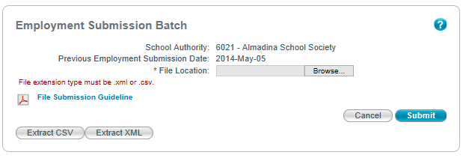

Threshold Error Messages:
Threshold errors are quality assurance checks to identify potentially significant variances or changes in key data values on the employment data being submitted. The threshold checks consist of name change percentage, address change percentage, contact change percentage, staff position change percentage, certificated staff total variance, failed records count. Threshold errors are reported via email with a link to the TWINS SAES Maintain Exception screen.
Example:
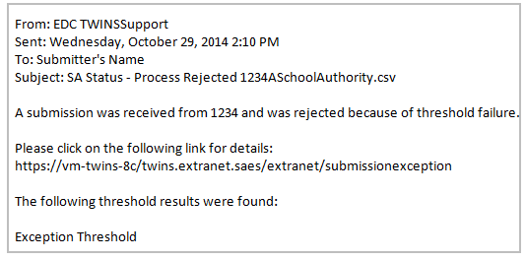

Data Error Messages:
Data exceptions are validation errors found within the individual records of the SAES file. An exception notice will be sent via email to the submitter if exceptions are found within the SAES file. The email will contain a link to the TWINS SAES Maintain Exception screen where the exceptions are listed and can be fixed.

Example:

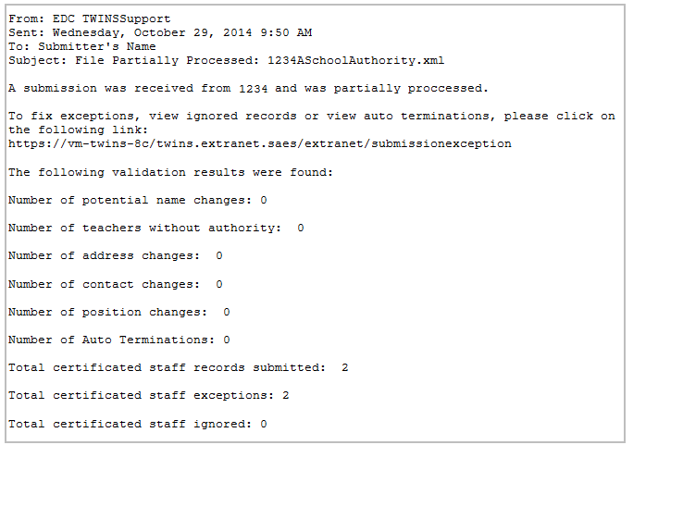

Exceptions:

Exceptions can be managed by selecting the ‘Manage Submission Exception’ menu item on the left menu of the TWINS application.

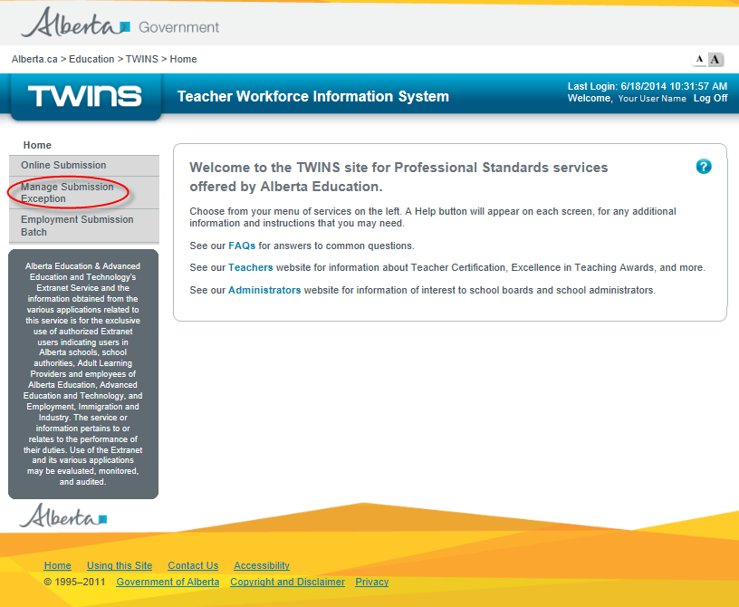

All exceptions for a specified submission file are listed as shown below:
Auto-termination exceptions will not stop the SAES file from being reconciled and cannot be ignored.If a school authority seed is submitted, for the specified school year, and certificated staff that were reported in the prior SAES seed submission period are missing an auto-termination exception will be generated.
Auto-termination exceptions will not stop the SAES file from being reconciled and cannot be ignored.

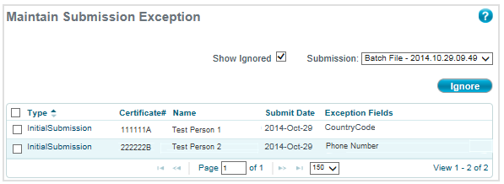

Any existing Initial submission data including the errors for the certificated staff member’s exception record can be updated . Please see Appendix A – Appendix A - Snapshot Data Format and RulesAppendix A - Snapshot Data Format and Rules Appendix A - Snapshot Data Format and RulesAppendix A - Snapshot Data Format and Rulesfor the format and rules of all the data fields.
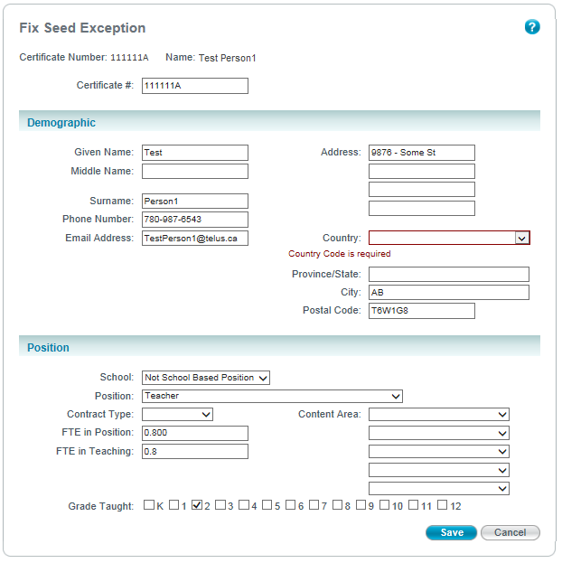Any existing seed data including the errors for the certificated staff member’s exception record can be updated by the Actor. Please see Appendix A – SAES Seed for the format and rules of all the data fields.
One or more exception records can be selected to be ignored by the Actor. When an exception record has been selected to be ignored it will no longer be displayed in the list of exceptions for that specified SAES file.
The exception items that have been selected to be ignored will be assigned a status of “Ignored”. An option for the Actor to list all ignored exceptions for that specified SAES file.

One or more exception records can be selected to be ignored. When an exception record has been selected to be ignored it will no longer be displayed in the list of exceptions for that specified SAES file.
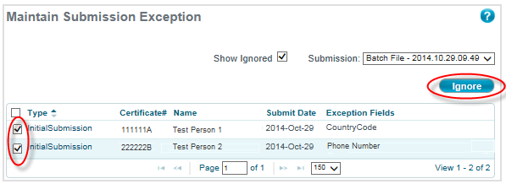

The exception items that have been selected to be ignored can viewed by the submitter by checking the ‘Show Ignored’ to list all ignored exceptions for that specified SAES file.

Auto Termination Exception:
If a school authority submits an Initial Submission for the specified school year and certificated staff that were reported in the prior submission period are missing, an auto-termination exception will be generated.

The User will be presented with the auto-termination exceptions listing the certificated staff member’s names and certificate numbers. The User can select the person from the list and determine if the person has been terminated or should have been included in the Initial submission for the current year.

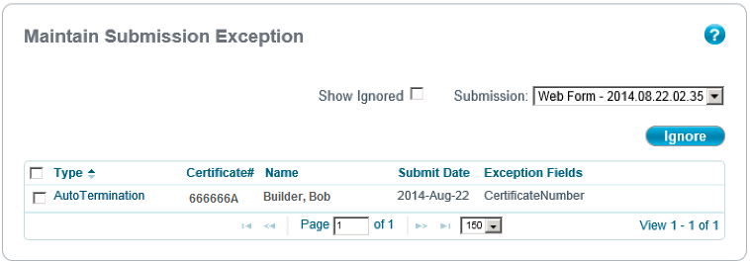

If the person has been terminated then the User must provide the following:
- Termination Date
- Termination Reason
- 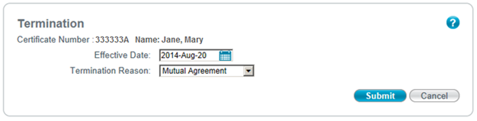• Termination DateThe Actor will be presented with the auto-termination exceptions listing the certificated staff member’s names and certificate numbers. The Actor can select the person from the list and determine if the person has been terminated or should have been included in the correction seed.
If the person has been terminated then the Actor must provide the following:
- Termination Reason
- Termination Date

Threshold Exception:
Threshold errors reported on the TWINS SAES Maintain Exception screen as follows:
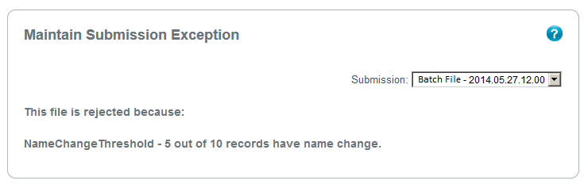
The file will be rejected and another submission meeting the threshold limitations must be sent so that it can be processed.

Appendix E - Access Request
The Extranet is a secure, authenticated electronic information service providing confidential data to Alberta Education Stakeholders for the purposes of carrying out their duties and responsibilities within the organization.
To obtain a User ID and Password, you must fill out this form completely and have it signed by the Authorized Officer of the organization. [TWINS (Teacher Registry) Authorization Form]
The completed form should be faxed to Teaching and Leadership Excellence at 780–422–4199 attention: Registry Manager.
Access – Description

Teacher Authority Validation (TAV)
This provides access to the Verify Teaching Authority (TAV) function for school authorities to verify teaching authority for a specified person.

Employment Submitter
This provides a school authority with access to submit certificated staff employment information to Alberta Education.
Recommending Officer
Designated Signing Authorities are provided with this access to complete a number of tasks online including:
- Apply for Alternate Teaching Authority
- Apply for an IPC Re-Issue / Extension
- Submit PPC Recommendation
- View submitted School Authority applications
- Request/View Signing Authorities
- View Cancelled and Suspended Certificates
School Authority Admin
This provides access to administration staff to draft requests and recommendations for teaching authority or signing authorities on behalf of the Recommending Officer. However, the Recommending Officer must submit the requests to Alberta Education.
Signing Authority Admin
This provides a school authority with access to create and maintain requests for adding and replacing signing authority on behalf of the school authority.

